Castner-Kellner process

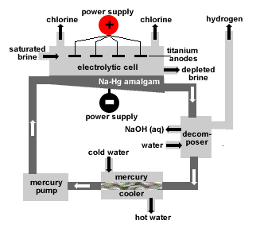

Fig: Castner-kellner cell

Castner-kellner cell :

It is a rectangular tank of steel. Inside of tank is lined with ‘ebonite.’

Anode is made of titanium.

Flowing layer of mercury (Hg) at the bottom of tank serves as cathode.

Process.

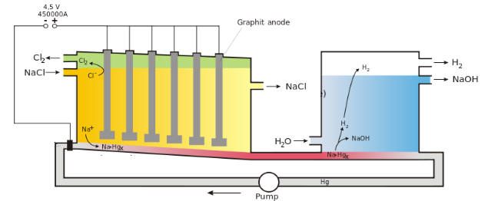

1. a saturated brine solution floats on top of a thin layer of mercury
2. The mercury is the cathode, where sodium is produced and forms a sodium-mercury amalgam with the mercury.
3. The amalgam is continuously drawn out of the cell and reacted with water which decomposes the amalgam into sodium hydroxide and mercury.
4. The mercury is recycled into the electrolytic cell.
5. Chlorine is produced at the anode and evaporates out of the cell.

Anode Reactions

|  |  |
| --- | --- |
|  |  |
| 2Cl- **è** Cl2 + 2e- | |
|  |  |

1. The anodes are placed in the aqueous NaCl solution, above the liquid mercury.
2. The reduction of Cl- occurs to produce chlorine gas, Cl2 (g).

2NaCl è 2Na+ + 2Cl-

Cathode Reactions

1. A layer of Hg (l) at the bottom of the tank serves as the cathode.
2. With a mercury cathode, the reaction of H2O (l) to H2 has a fairly high over potential, so the reduction of Na+ to Na occurs instead.
3. The Na is soluble in Hg (l) and the two combine to form the Na-Hg alloy amalgam.

2Na+ +2 e- è 2Na

Na forms amalgam.

Na + Hg è Na/Hg

1. This amalgam can be removed and then mixed with water to cause the following reaction:

2Na(inHg)+2H2O→2Na++2OH−+H2(g)+Hg(l)

1. The Hg (l) that forms is recycled back into the liquid at the bottom of the tank that acts as a cathode.
2. H2 gas is released.
3. NaOH is left in a very pure, aqueous form

Advantages

1. NaOH obtained is highly pure
2. The process is very efficient.
3. Possible reaction between N byaOH and Cl2 is avoided as NaOH is obtained in a separate chamber.

Disadvantages

1. High electricity consumption.(3400 kWh/ton Cl2 opposed to 2500 in a diaphragm cell)
2. Environmental pollution due to escape of Hg vapours.

Nelson Diaphragm Cell

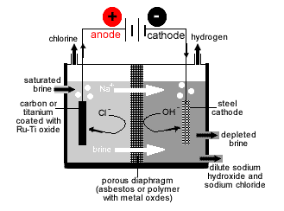

1. Porous diaphragm of asbestos or metal oxide with polymer separates anode and cathode compartments.
2. Diaphragm prevents hydroxide ions entering anode compartment and prevents chloride ions entering cathode compartment.
3. Saturated brine enters anode compartment where chlorine gas is produced.
4. Anode (positive electrode): carbon (graphite) or titanium coated with Ru-Ti oxide.
5. Anode reaction (oxidation): 2Cl-(aq) → Cl2(g) + 2e-
6. Cathode (negative electrode):

steel mesh

Cathode reaction (reduction):

2H2O(l) + 2e- → H2(g) + 2OH-(aq)

7. Na+ migrates across diaphragm to cathode compartment combining with OH- to form NaOH.

8. Overall cell reaction (showing Na+ spectator ions):

2H2O(l) + 2Cl-(aq) + 2Na+(aq) → 2Na+(aq) + 2OH-(aq) + H2(g) + Cl2(g)

9. Product contains sodium chloride and sodium hydroxide. NaOH(s) can be crystallised out.